There have been many dose calculation systems introduced over the years to address planar and volume brachytherapy implants. These systems present rules for the source distribution, the optimal source activity, and the dose specification.¹ The three main systems are Manchester (Paterson-Parker), Paris, and Quimby. I have chosen the Quimby system for this discussion.
The Quimby system is named after Edith Quimby, who published the first paper on the system in 1932.¹ Ra-226 was the most commonly used isotope for brachytherapy in the 1930s. Sources of equal linear activity are uniformly spaced throughout the implant, resulting in a non-uniform dose distribution.^{1,2} Typically, the center region of the implant is substantially hotter compared to the periphery of the implant, as the isodose lines bulge out in the center.³ This system is used for both planar and volume implants.²
The dose distributions for linear Ra-226 sources with varying wall thicknesses and lengths were calculated by Quimby.³ This data provides the dose rates (cGy/hr) at points along the away from the axis of a 1-mg radium source.^{3,4} The distance used for the “along” table is the distance measured from center going parallel with the source and the distance used for the “away” table is distance measured perpendicular to the source to the point in question.⁴ To find the dose rate to a specified point, the dose rates contributed by the individual sources must be found and added together. The distance along the implant from the center to where the point in question is located and the distance the point is located away from the implant are used to find the cGy/mg hr for each source. This value is multiplied by the mg of the source to find the cGy/hr. These values are added together to get the total dose rate to the point in question. Below is an example of the calculation to find the dose to a point (P) utilizing the Quimby tables:
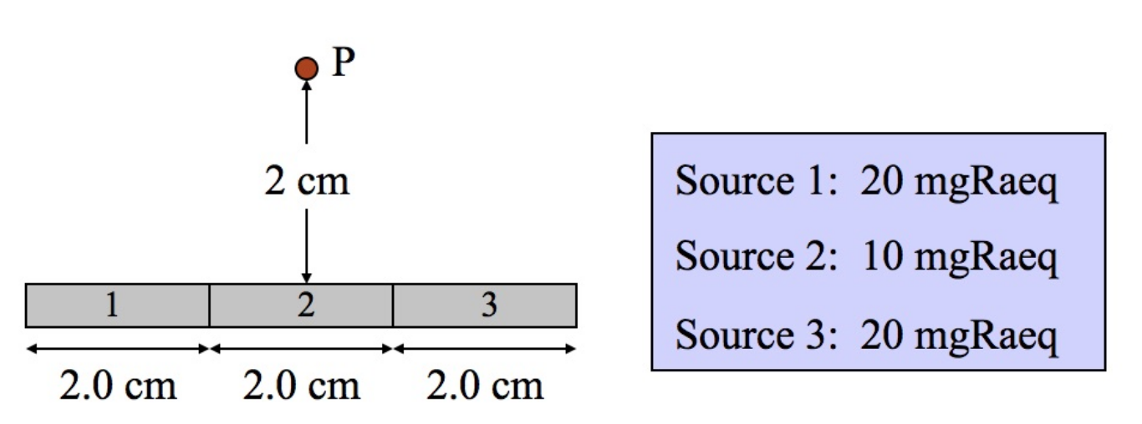

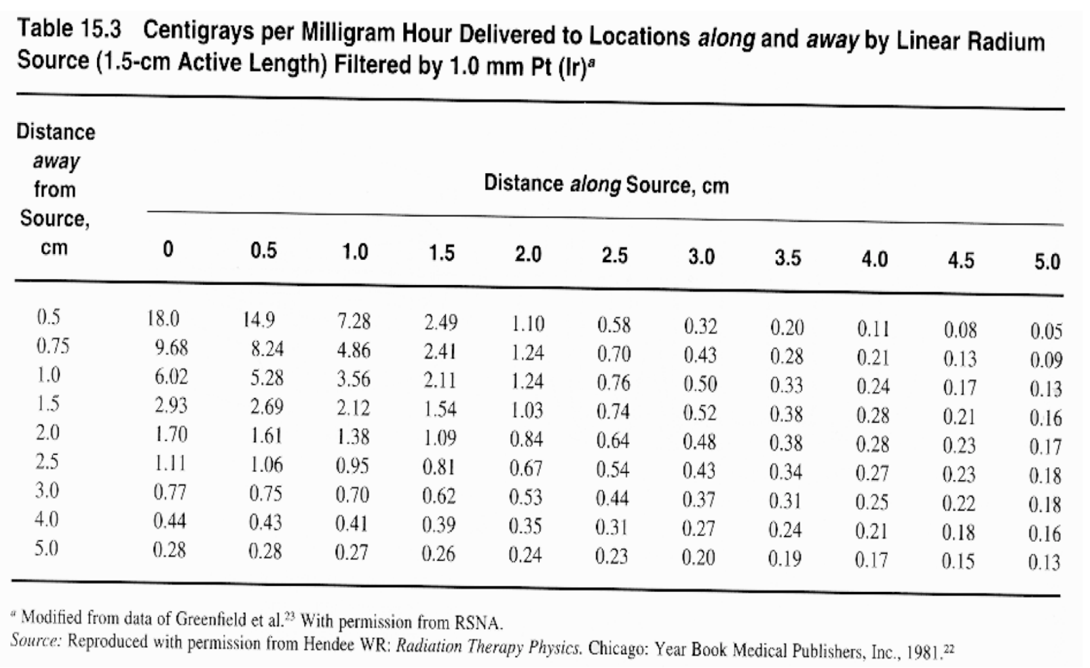

Source 1 (2 cm along, 2 cm away)
0.84 cGy/mg hr X 20 mg = 16.8 cGy/hr

Source 2 (0 cm along, 2 cm away)
1.7 cGy/mg hr X 10 mg = 17.0 cGy/hr

Source 3 (2 cm along, 2 cm away)
0.84 cGy/mg hr X 20 mg = 16.8 cGy/hr

Total dose rate to point P = 50.6 cGy/hr

The Quimby system has its disadvantages. It does not account for scattering and attenuation of photons and does not take into account the filtration at all angles.¹ Because of this, the Quimby system should not be used for sources that have energies below 200 keV. The original tables for the Quimby system used the exposure rate constant of 8.4 R-cm²/mg-h for Ra-226 as opposed to current value of 8.25 R-cm²/mg-h.² The Quimby system has since been adapted to use computer calculated tables that account for oblique filtration and presents the values in modern units.³ This is referred to as the Memorial system.

References
- McDermott PN, Orton CG. The physics & technology of radiation therapy. Madison, WI: Medical Physics Publishing; 2010:16-24,16-25.
- Khan FM, Gibbons JP. Khans the physics of radiation therapy. 5th ed. Philadelphia: Wolters Kluwer Health; 2014.
- Bentel GC. Radiation Therapy Planning. 2nd ed. New York, NY: McGraw-Hill; 1992:544-549.
- Lenards N, Berner P, Berner P, Schmidt K. LDR Intracavitary Implants. [Softchalk]. La Crosse, WI: UW-L Medical Dosimetry Program; 2016.

