The sharp dose falloff of radionuclides is a key concept of brachytherapy.¹ Because of the short treatment distance, surrounding healthy structures can be spared while the treatment volume receives optimal dose coverage. Brachytherapy can be delivered using a variety of applicators, including external molds, interstitial implants, and intracavitary instruments.² The type of applicator used is determined by the extent and anatomical location of the tumor or lesion. One example of a surface applicator is the Freiburg Flap.
The Freiburg Flap is a flexible planar sheet made up of silicone balls that are linearly connected to one another to form a single layer (Figure 1).³ Up to 36 6-French catheters are inserted into the hollow channels within the rubber spheres. The size and shape of the Freiburg Flap is able to be customized to the patient by using different areas of rubber balls in increments of 1 cm. The beads keep the catheters evenly spaced and keeps the distance between the catheter and the surface consistent. Because of its flexibility, it is able to conform to surfaces that are not strictly flat, which is beneficial, especially considering how sloped some areas of the body are.
The advantages of brachytherapy, specifically the Freiburg Flap, over the use of electrons are that the dose to the surface is significantly higher and there is less dose received by tissue beyond the designated treatment volume. Because of these characteristics, the use of the Freiburg Flap is extremely common for the treatment of skin cancer. Though the Freiburg flap is most commonly used for superficial external lesions, it can also be used intraoperatively for certain cases. Since 2006, Johns Hopkins has performed 87 intraoperative brachytherapy treatments using the Freiburg Flap.³ One case was a 39 year old male with locally advanced rectal cancer. The patient received chemotherapy and external beam radiation therapy of 54 Gy. Progression was detected on CT and the patient underwent a total pelvic exenteration and a Freiburg Flap was used to deliver 15 Gy to the entire pelvis (Figure 2). It was reported that the patient did well post-operatively and that he did not experience any further complications.
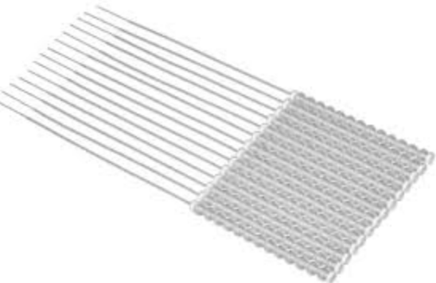
Figure 1. A Freiburg Flap with catheters inserted into the channels.
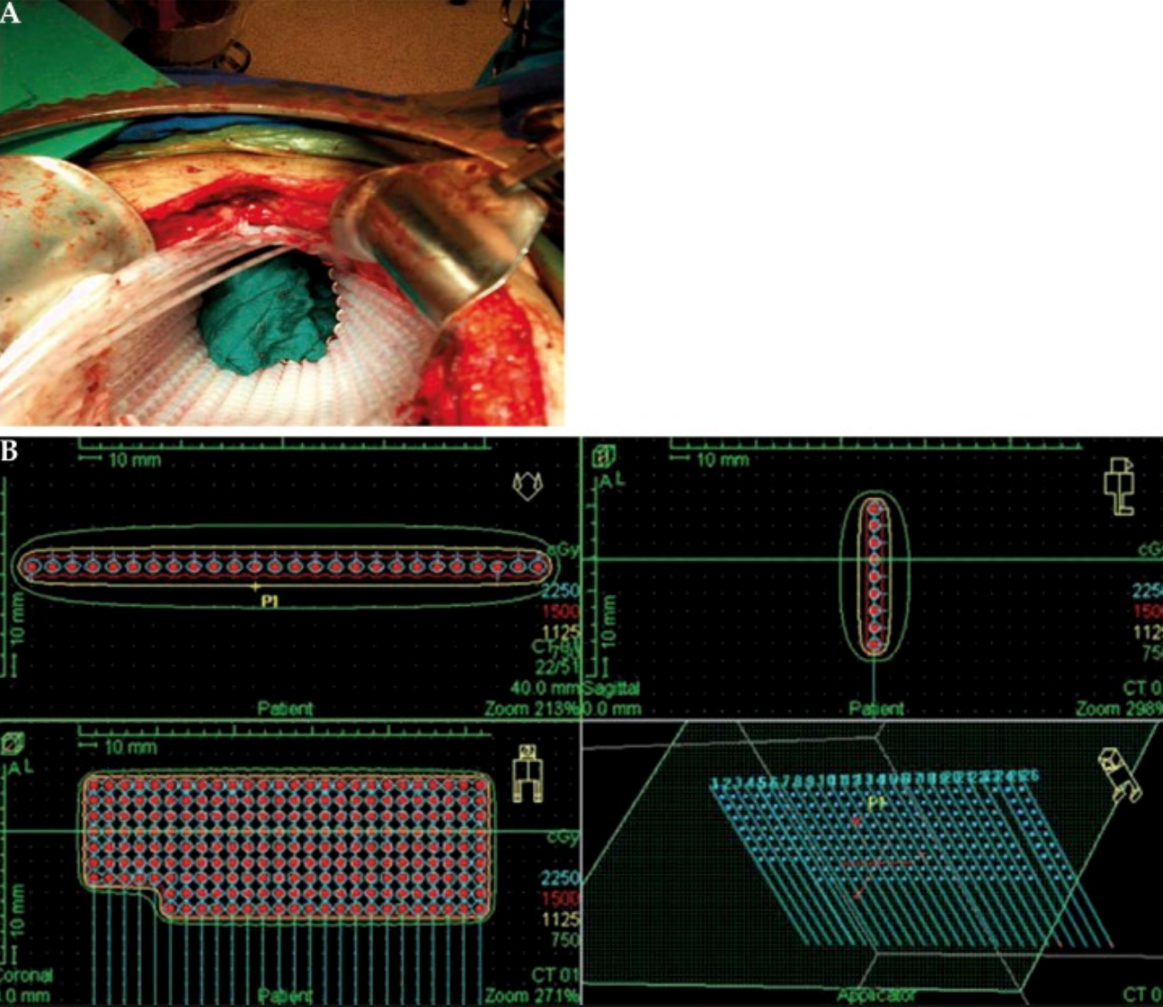
Figure 2. (A) A Freiburg Flap being used for the intraoperative treatment of locally advanced rectal cancer. (B) The dosimetric plan showing the dose distribution of the prescribed 15 Gy to the entire pelvis surface.
References
- Lenards N, Brachytherapy Implants-Introduction. [SoftChalk]. La Crosse, WI. UW-L Medical Dosimetry Program;2016.
- Khan FM. The Physics of Radiation Therapy. 4th ed. Baltimore, MD: Lippincott, Williams, and Wilkins; 2010:341-342.
- Moningi S, Armour EP, Terezakis SA, et al. High-dose-rate intraoperative radiation therapy: the nuts and bolts of starting a program. Journal of Contemporary Brachytherapy. 2014;6(1):99-105. doi:10.5114/jcb.2014.42027.

