Comparison of Lung Treatment Planning with and without the use of Heterogeneity Corrections
Introduction: The most prevalent malignancy in the United States for both men and women is lung cancer, with exposure to tobacco being the most common cause.¹ The primary treatment for lung cancer patients is typically surgical resection, such as a pneumonectomy, lobectomy, or wedge resection, depending on the location and extent of the malignancy.² Whether it is postoperative, concurrent, or the primary treatment for inoperable cases, radiation therapy is routinely recommended and used for the treatment of lung cancers.² Prior to the use of computed tomography (CT), it was difficult to account for the various layers of differing densities, such as fat, muscle, lung, bone, soft tissue, and air, that the beam would traverse through during treatment.³ These inhomogeneities attenuate the beam differently and affect the dose distribution. Today, the use of CT during the simulation process for radiation therapy treatments is common practice and provides the necessary data to account for the various densities within the human body during treatment planning. This project compares and discusses lung treatment plans created with and without the utilization of heterogeneity correction factors.
Methods and Materials: A treatment planning CT scan was completed on a patient diagnosed with stage III (T3 N1 M0) adenocarcinoma of the left lower lobe with the tumor measuring 6x4.2x6.1 cm. The CT data was imported into the Phillips Pinnacle treatment planning system (TPS) and the normal structures, which included the external, right and left lungs, heart, and spinal cord, were contoured. The radiation oncologist reviewed and approved the normal structure contours and contoured the target structures, including the GTV, CTV, and PTV. The CTV was created by expanding the GTV by 0.3 cm and the PTV was created by expanding the GTV by 0.5 cm. These expanded margins account for daily setup variability, movement within the patient, and microscopic disease. Once the contours were finished, the radiation oncologist completed a treatment planning order (TPO) that included the prescribed dose, dose per fraction, and the number of fractions for this patient. This patient was prescribed a total dose of 50 Gray (Gy) in 25 fractions, at 2 Gy per fraction, normalized to the 100% isodose line.
The isocenter was centrally placed in the designated PTV volume and an anterior-posterior (AP) beam and a posterior-anterior (PA) beam were created at angles of 0˚ and 180˚, respectively. Multi-leaf collimation (MLC) was used to create the beam field shapes, with a 2.0 cm margin around the PTV allowing for optimized coverage of the target volume while sparing as much normal healthy tissue as possible. The beam energy assigned to both the AP and PA beams was 6 MV. The AP beam was weighted 40.8% and the PA was weighted 59.2%. To demonstrate the effect of heterogeneity correction factors, the first plan was calculated using heterogeneity correction factors and a second plan, with identical parameters as the initial, was calculated without the use of heterogeneity correction factors.
Results: When comparing both plans created with and without the use of heterogeneity correction factors, there are distinct differences between them. Figure 1 shows the isodose distribution for the plan created with the use of heterogeneity correction factors in the axial, sagittal, and coronal views. It should be noted that there is a large area of 110% of the prescribed dose (red isodose line) generally close to the anterior and posterior surfaces of the patient, but also a small amount going through the medial portion of the patient and PTV due to the low energy of the beam and because the lung is relatively the same density as air, attenuating very little of the beam. The isodose lines are somewhat jagged because of the attenuation of the different densities the beam is traveling through. In comparison, figure 2 depicts smooth, conformal isodose lines as a result of the heterogeneity correction factors being omitted for this plan. When the heterogeneity corrections factors are turned off the TPS assumes that the entire patient is the same density which causes a much more uniform isodose distribution. The area of 110% of the prescription dose (red isodose line) in the plan that did not use heterogeneity correction factors is concentrated only at the anterior surface of the patient.
A dose volume histogram (DVH) graphically illustrates dose received by a certain amount of volume of a contoured structure. It is a valuable tool when evaluating treatment plans because there is a great deal of information provided for each structure, including the maximum dose, minimum dose, and mean dose. Figure 3 and 4 the DVHs of the plan calculated with and without heterogeneity correction factors, respectively. By comparison, the line representing the PTV for the plan without the use of heterogeneity correction factors illustrates that there is better coverage and rapid fall off of dose, which is more ideal dosimetrically. While the coverage is greater for the plan without heterogeneity correction factors, the dose to the critical structures is higher and the hotspot is 63.8 Gy, which is 0.5 Gy hotter than the hotspot of the plan with heterogeneity correction factors.
When comparing the monitor units for each plan illustrated in figures 5 and 6, more monitor units are required to deliver the prescribed dose to the target volume for the AP field and less monitor units are needed for the PA field for the plan omitting the heterogeneity correction factors. For the plan calculated with heterogeneity correction factors, the monitor units for the AP and PA field at 118 and 137, respectively. The monitor units for the AP and PA field for the plan that did not use heterogeneity correction factors are 137 and 135, respectively. By the TPS neglecting to account for the various tissue densities the beam travels through and assuming the entire patient is the same density as water when, in fact, lung is much less than dense than water, it is understandable that the monitor units for the AP beam of the plan that does not use the heterogeneity correction factors is higher. Essentially, water attenuates more of the beam than lung, thus more monitor units are needed to deliver the same dose for the plan that assumes homogeneity. It is more difficult to explain the lower monitor units for the PA field of the plan that omits the heterogeneity correction factors when it is expected that they would be higher than the plan that uses heterogeneity correction factors. Because the PTV is more posterior resulting in less lung tissue between the patient’s posterior surface and target volume, the PA beam is weighted more, and because there is a sizable amount of bone, which is a higher density than water, in the path of the beam, it is logical that the combination of these factors would result in higher monitor units for the PA beam of the plan assuming homogeneity.
Discussion: Although standardized depth dose tables and isodose charts assume homogeneity, the human body consists of various layers of tissue with different densities that affect the dose distribution.³ These inhomogeneities effect the absorption of the primary beam and the secondary electron fluence.³ Because Compton scatter is the predominant interaction for beam energies used for radiation therapy treatments, the electron density of the medium the beam is traveling through dictates the amount of the beam that is attenuated.³ Essentially, the higher the density, the more the beam is attenuated. Before the use of CT was common practice in radiation oncology facilities, the isodose shift method was used to try and account for tissue inhomogeneities, where the isodose lines were shifted towards the skin for higher densities and away from the skin for lower densities based on the thickness of the tissues.³ However, it was difficult to accurately identify the amount of tissues due the imaging technology at the time.
Heterogeneity correction factors used for treatment planning account for the different densities of the tissues the beam encounters and produces a more accurate dose distribution. A plan omitting heterogeneity correction factors assumes the patient entirely the density of water. Water is denser than lung tissue and in the case of creating a lung treatment plan, the TPS would assume that the beam will attenuated more for a plan without heterogeneity correction factors. In a study conducted by Ding et al⁴, they compared identical lung stereotactic body radiation therapy treatment plans using the same monitor units, with and without the use of heterogeneity correction factors. They found that the equivalent uniform dose (EUD) and the tumor control probability (TCP) were significantly lower for the plans that omitted heterogeneity correction factors compared to the plans that utilized heterogeneity correction factors.⁴ By assuming the patient is homogeneous and assigning a water-equivalent density to the entire body, the same number of monitor units required to successfully deliver the prescribed dose for the plan calculated using heterogeneity correction factors is not sufficient since lung tissue attenuates the beam less than water, and thus depicts an underdose of the target volumes. This study indicates the necessity of implementation of heterogeneity correction factors for radiation therapy treatment planning.
At first glance, the dose distribution for the plan without heterogeneity correction factors looks much more optimal compared to the plan with heterogeneity correction factors, but it is unrealistic and not an accurate depiction of what is happening to the dose within to patient. Without the use of heterogeneity correction factors, the probability of severely underdosing the target volume or delivering higher doses to surrounding critical structures is greatly increased, which could lead to recurrence or harm to the patient.
Conclusion: When a plan is created without the use of heterogeneity correction factors, the TPS assumes that the patient is roughly the density of water throughout. Although this produces smooth isodose lines and a generally more aesthetically pleasing dose distribution, it is not an accurate portrayal of the dose. Since the plan created without the use of heterogeneity correction factors calculated higher MU than the plan that used heterogeneity correction factors, neglecting to take into account that the beam is traversing though lung, which is less dense than water, could potentially overdose the patient and increase dose to surrounding critical structures. Although there are some rare instances, such as treating an area with a prosthetic or metal hardware, in which is it can be advantages to omit the use of heterogeneity correction factors, in general, utilizing heterogeneity correction factors produces a more accurate depiction of the dose distribution and ultimately allows the most optimal plan to be designed for the patient.
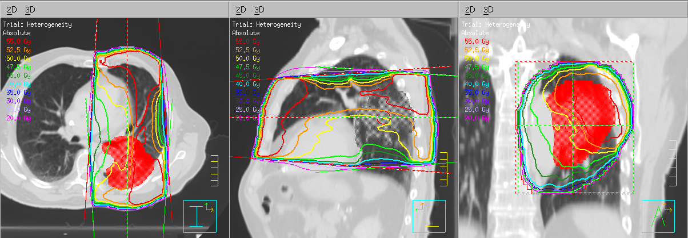
Figure 1. Visualization of the isodose lines of the treatment plan using heterogeneity correction factors in the axial, sagittal, and coronal views.

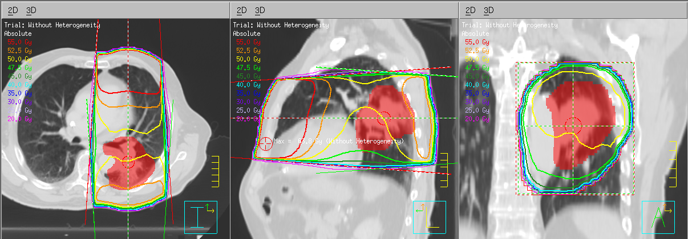
Figure 2. Visualization of the isodose lines of the treatment plan without using heterogeneity correction factors in the axial, sagittal, and coronal views.
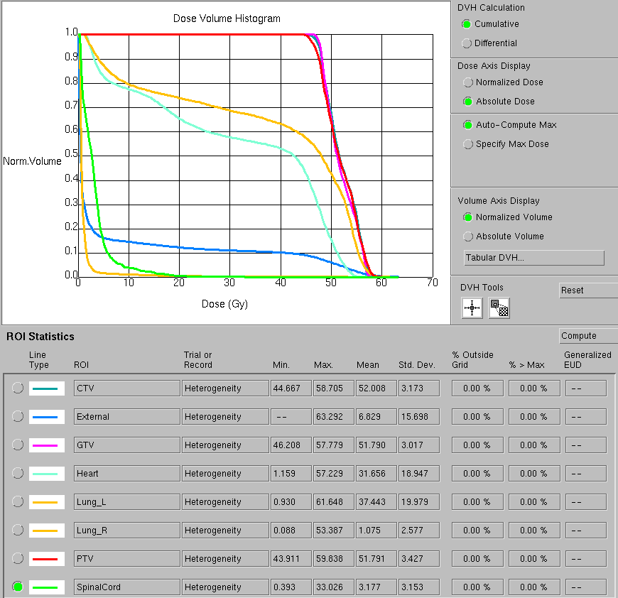
Figure 3. Dose volume histogram of the treatment plan using heterogeneity correction factors.
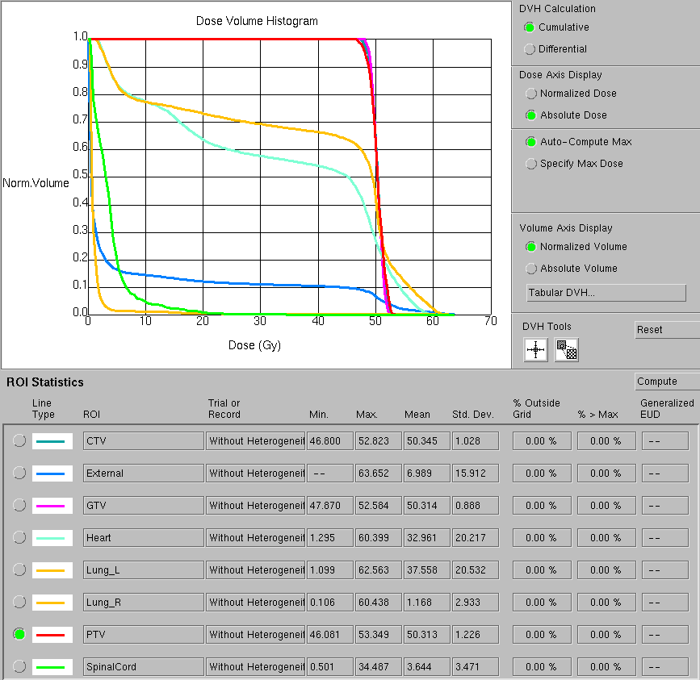
Figure 4. Dose volume histogram of the treatment plan without using heterogeneity correction factors.
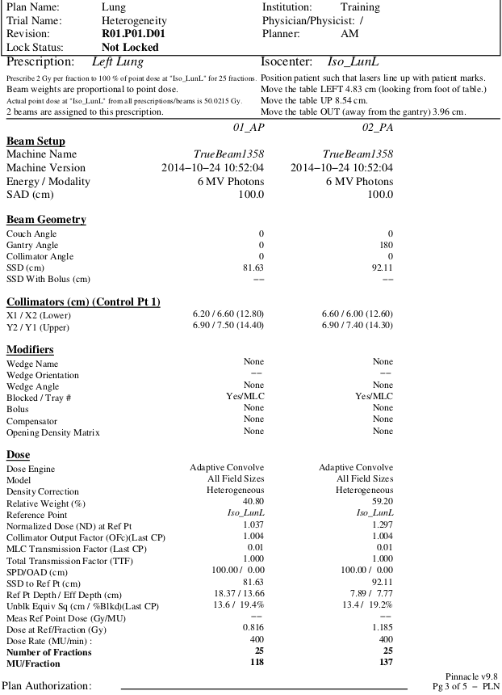
Figure 5. Monitor unit calculations of the treatment plan with heterogeneity correction factors.
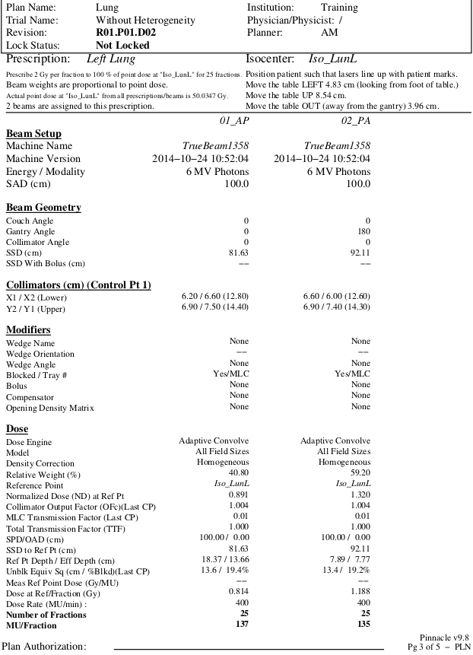
Figure 6. Monitor unit calculations of the treatment plan without heterogeneity correction factors.

References
1. Washington CM, Leaver D. Principles and Practice of Radiation Therapy. 3rd ed. St. Louis, MO: Mosby-Elsevier; 2010.
2. Bentel GC. Radiation Therapy Planning. 2nd ed. New York City, NY: McGraw-Hill Companies; 1996.
3. Khan FM. The Physics of Radiation Therapy. 5th ed. Philadelphia, PA: Lippincott Williams & Wilkins; 2014.
4. Ding M, Kananagh B, Schefter T, Stuhr K, Newman F. The Influence of Heterogeneity Corrections on Tumor and Normal Lung Dosimetry in Stereotactic Body Radiation Therapy for Lung Cancer Treatment. International Journal of Radiation Oncology Biology Physics. 2005;63.

