With more than 55,000 people in the U.S. being diagnosed with head and neck cancers every year, it is very likely that every individual has been touched by this disease, in some form or another. Head and neck malignancies can be devastating to not only the patients going through this ordeal, but their family and friends, as well. This year, the University of Wisconsin put on the 11th annual Heads Up! golf outing for the community to raise awareness of head and neck cancers, raise money for continued research, and provide support, both emotionally and financially, to those currently going through treatments.
The 11th annual Heads Up! golf outing was held at University Ridge in Verona, WI (Figures 1 and 2). We had 134 golfers participate in the scramble and over 200 people attend the dinner following the golf outing. The attendees included physicians and employees from the hospital, current and past patients and their family and friends, and those in the community that just wanted to come out for a great cause.
Prior to the participants arriving, I assisted in putting together the gift bags that every golfer received, which included a sleeve of golf balls, glasses cleaner, and Jolly Ranchers. These were distributed in the golf carts. Once this was completed, I was stationed at the registration table to help check in golfers, take donations for the scholarships and research, and sell raffle tickets. This was a shotgun start scramble that started at 12:00 pm so people started arriving at around 10:30 am to register. Once a golfer was registered, they went inside the clubhouse for lunch and could participate the in silent auction that included donated items from the University of Wisconsin and individuals from the community (Figure 3). After the scramble started, we set up the tables for the dinner that followed the outing. During dinner, the winners of the golf outing and hole prize recipients were announced, 2 former patients spoke about their journeys throughout their diagnoses and treatments, and a panel of head and neck medical oncologists, radiation oncologists, and surgeons spoke (Figure 4 and 5).
This was truly an amazing event to have been able to be a part of. Not only because it was such a beautiful day, weather wise, but because I got to see the impact the community had on those that were touched by head and neck cancers. Many of the attendants have been coming since the first time this event took place. These people have built relationships and support for each other through this golf outing. I feel like sometimes it can seem like one person can’t make a difference for something as big as head and neck cancers, but at events like this, where I am able to speak with and see the interactions of those that have been impacted, something as small as just listening and giving a hug can mean the world. I was blown away and inspired by the involvement of the community and seeing how much they wanted to support this cause. I truly hope to continue to be a part of this event for years to come.

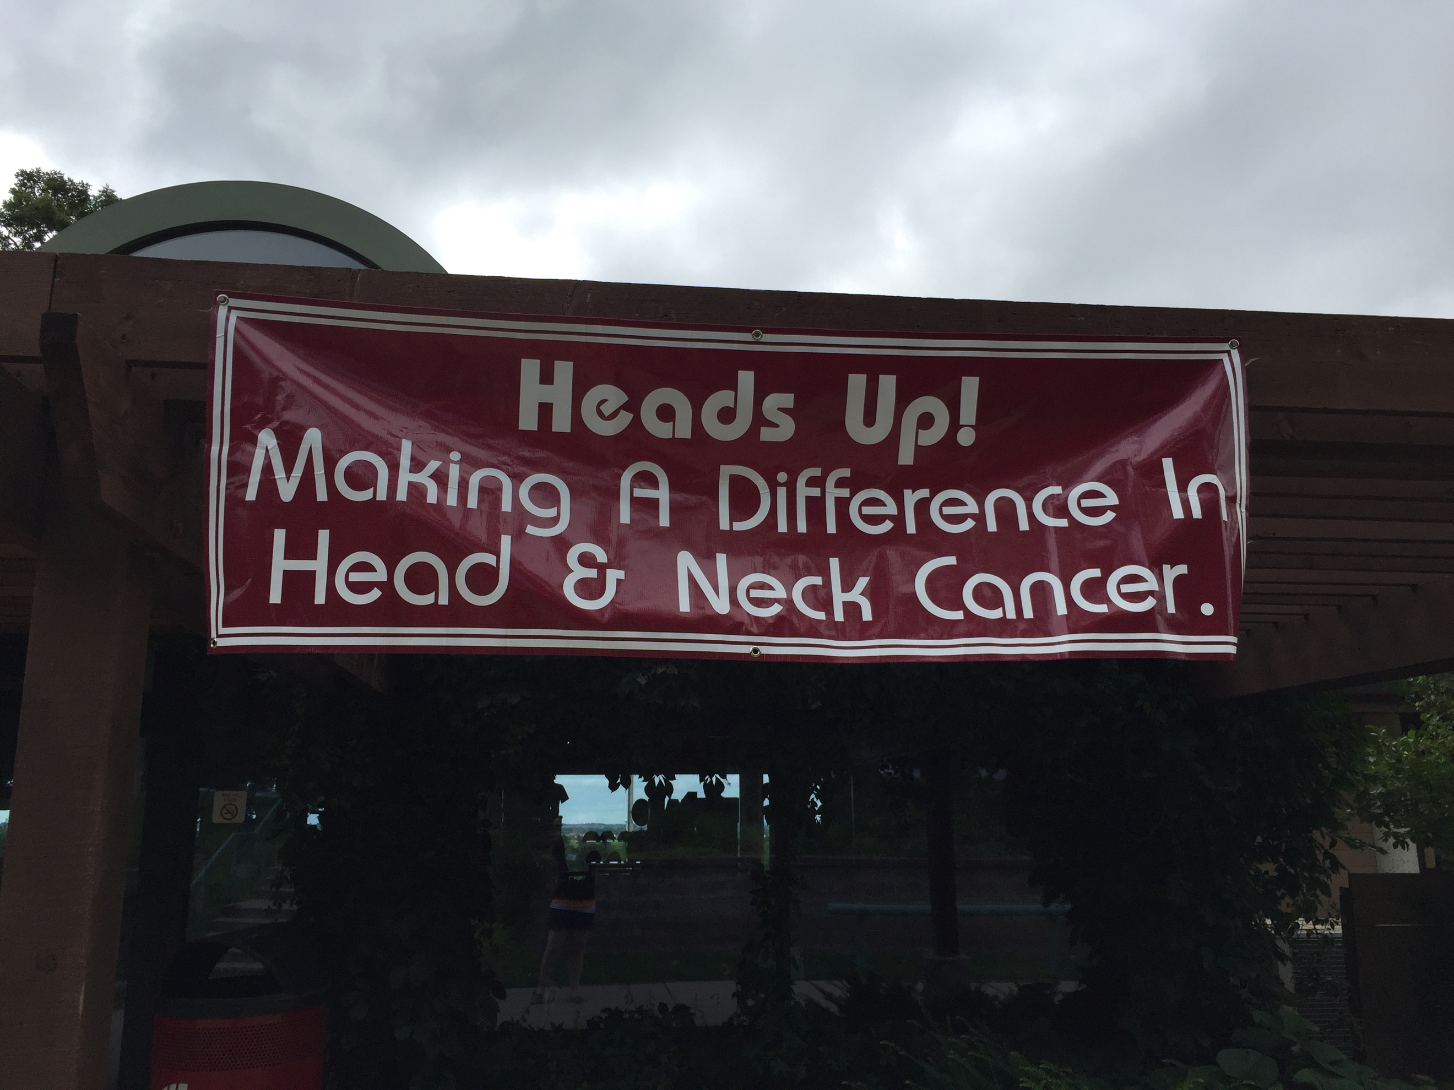
Figure 1. Banner that hung over the registration table.

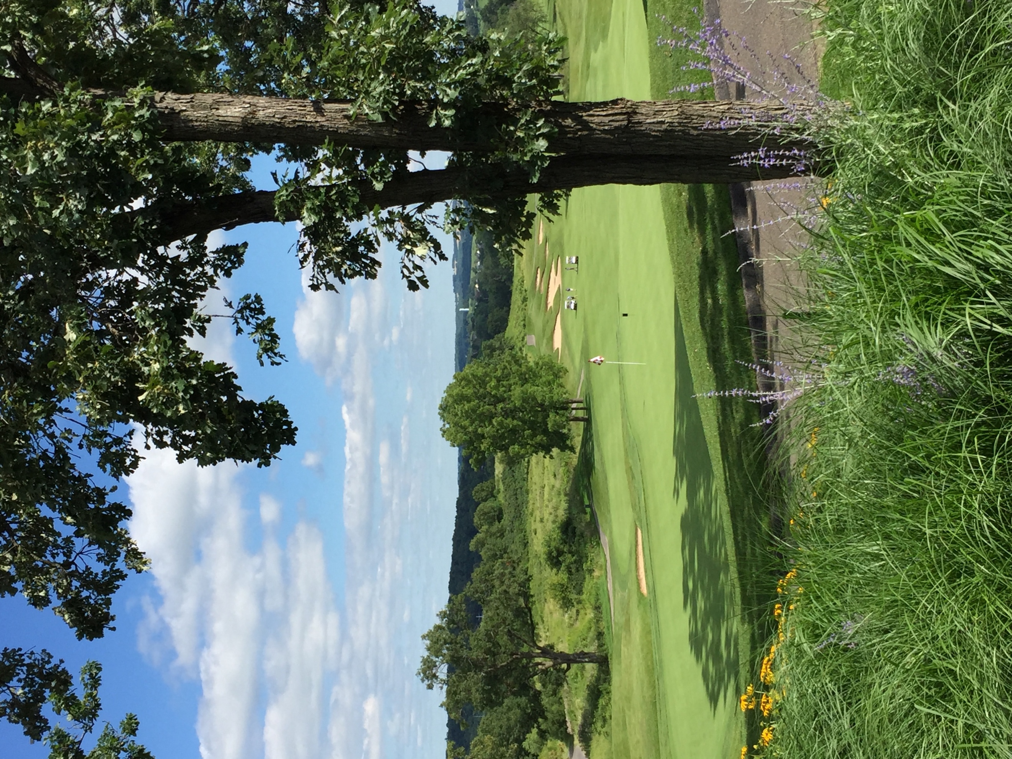
Figure 2. View of the Ninth hole at University Ridge in Verona, WI.

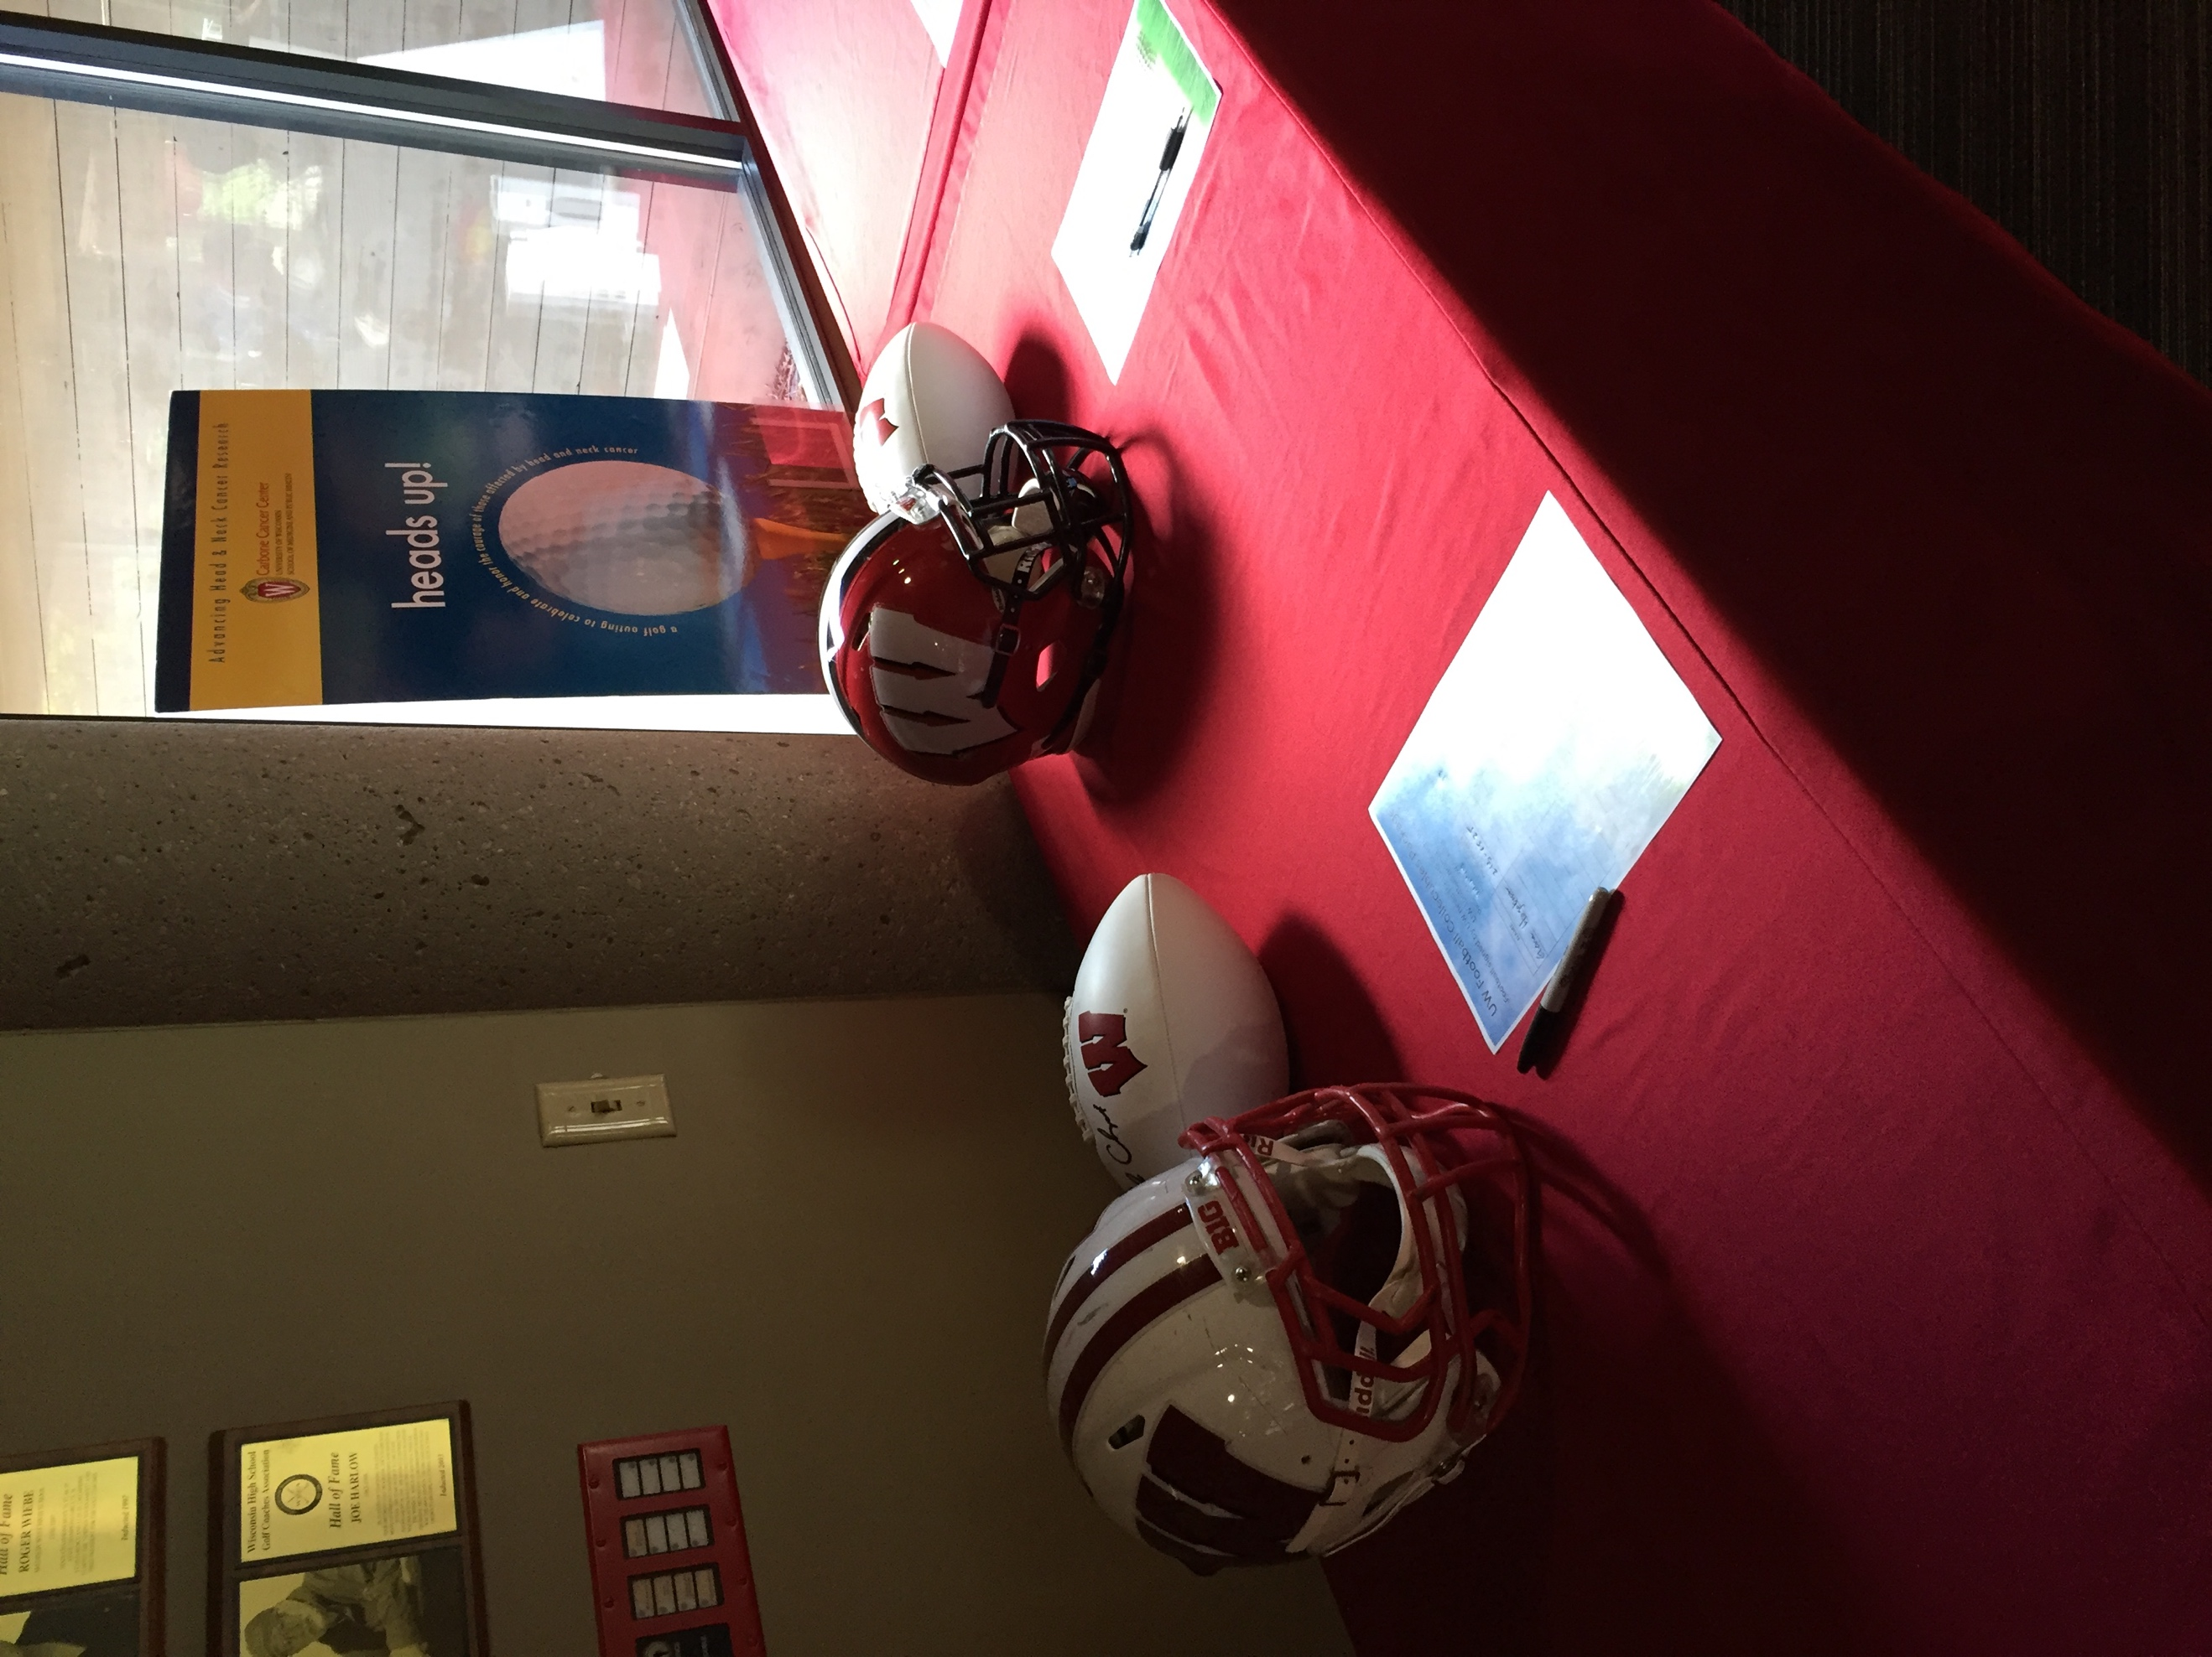
Figure 3. Silent auction table which includes autographed football helmets and footballs, tickets to Badger hockey and basketball games, and University Ridge gift cards and rounds of golf, among other items.

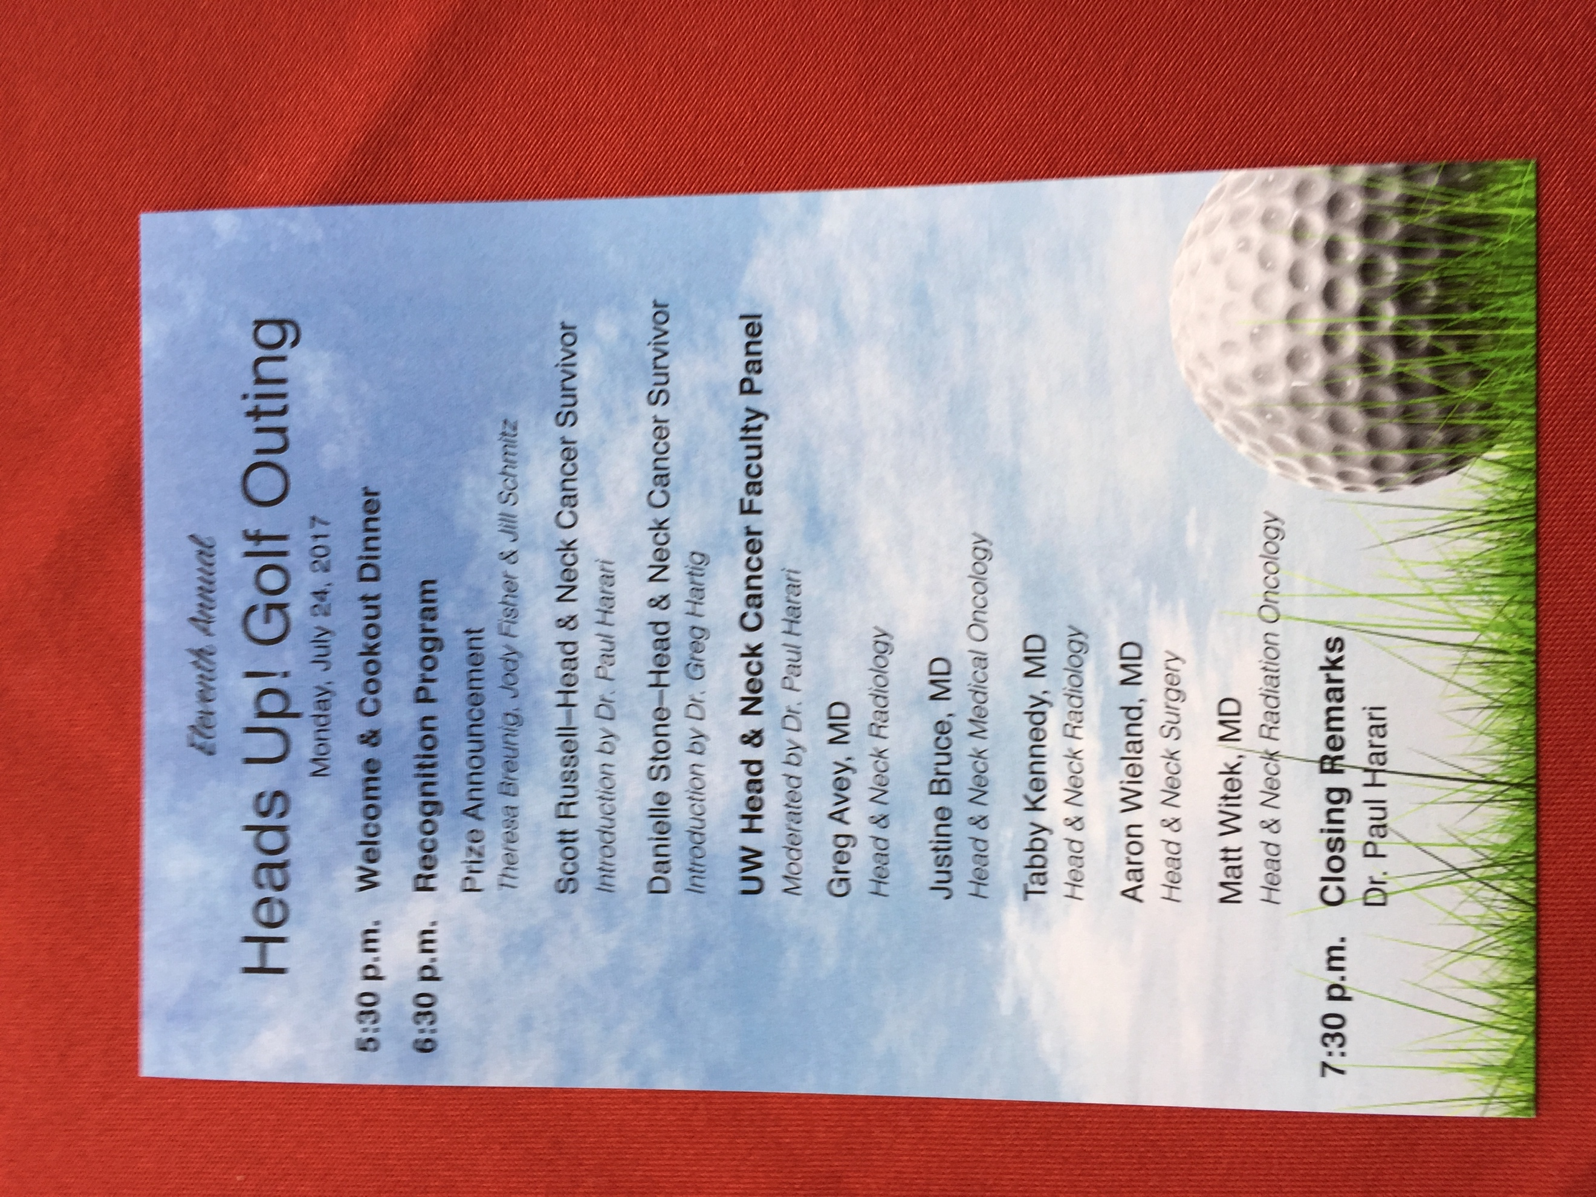
Figure 4. Schedule of events for the dinner following the golf outing.

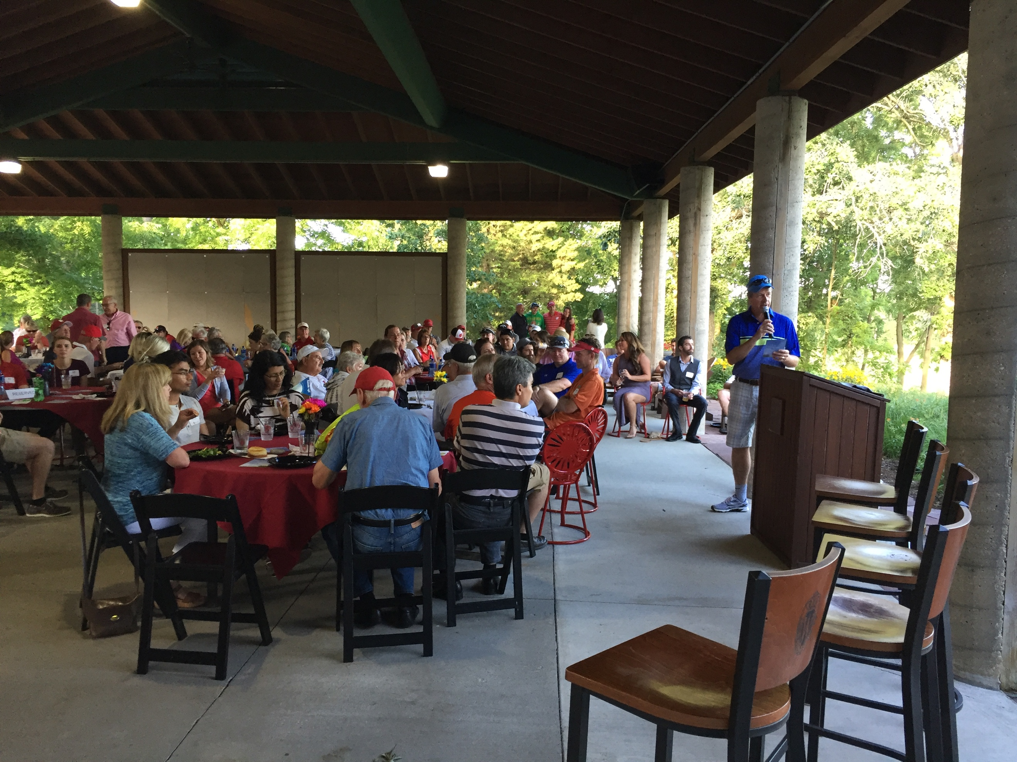
Figure 5. Dr. Harari from the University of Wisconsin Hospital delivering the welcome for the dinner.

