Flattening Filter Free (FFF) Beam Dosimetry

The profile of a photon beam is not flat and uniform. Rather, it is has a higher intensity in the center of the beam and it is less intense around its boarders.¹ To achieve uniformity across the beam, a flattening filter may be inserted into the path of the beam.^{1,2} Flattening filters resemble the shape of a sombrero in that they are thicker in the center and thinner near the edges (figures 1 and 2). They align with the beam so that the part of the beam with the higher intensity, which requires increased attenuation, is going through the thickest part of the flattening filter, resulting in a flatter, more uniform beam profile (figure 3). Although a uniform intensity across a field is important for 3D treatment techniques, it is essentially irrelevant for intensity modulated radiotherapy (IMRT) and volumetric arc therapy (VMAT) because, inherently, intensity is not flat for these techniques and this variation in intensity can be accounted for during inverse optimization.^{1,2}

With beam uniformity not being an issue for IMRT and VMAT treatment techniques, many vendors have begun introducing machThe profile of a photon beam is not flat and uniform. Rather, it is has a higher intensity in the center of the beam and it is less intense around its boarders.¹ To achieve uniformity across the beam, a flattening filter may be inserted into the path of the beam.^{1,2} Flattening filters resemble the shape of a sombrero in that they are thicker in the center and thinner near the edges (figures 1 and 2). They align with the beam so that the part of the beam with the higher intensity, which requires increased attenuation, is going through the thickest part of the flattening filter, resulting in a flatter, more uniform beam profile (figure 3). Although a uniform intensity across a field is important for 3D treatment techniques, it is essentially irrelevant for intensity modulated radiotherapy (IMRT) and volumetric arc therapy (VMAT) because, inherently, intensity is not flat for these techniques and this variation in intensity can be accounted for during inverse optimization.^{1,2}

With beam uniformity not being an issue for IMRT and VMAT treatment techniques, many vendors have begun introducing machines that offer a flattening filter free (FFF) mode.² By removing the flattening filter from the beam’s path, the mean energy is decreased, which results in increased skin dose, and the dose rate is increased, up to 2400 monitor units (MU) per minute for 10 MV FFF.¹ The FFF mode can be utilized to deliver treatments with high doses, including stereotactic body radiation therapy (SBRT) and stereotactic radiosurgery (SRS).¹ With its higher dose rate, FFF provides an advantage for treatments requiring gating as it would take less time to deliver the radiation treatment.

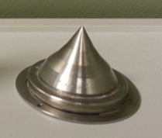
Figure 1. Flattening Filter
https://www.astro.org/Affiliate/ARRO/Resident-Resources/Educational-Resources/Image-Challenge/Content-Pieces/Physics-1/
Figure 2. Sombrero
http://globalconnections.champlain.edu/2014/11/26/sombrero/
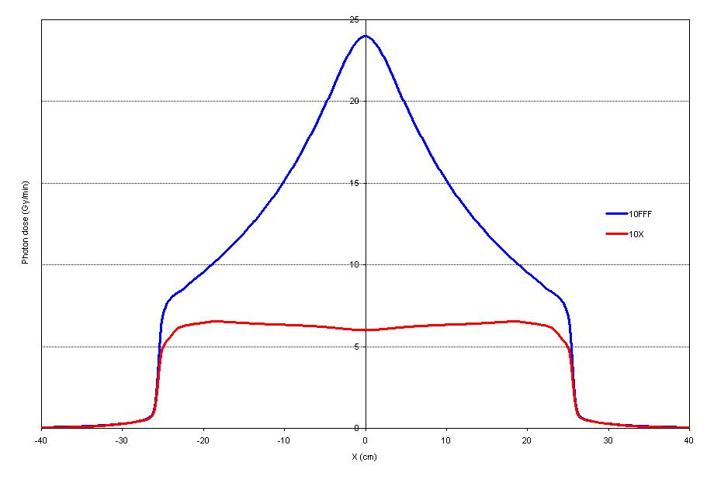
Figure 3. Comparison of a 10 MV beam profile with a flattening filter in its path (the red line) and a beam profile without a flattening filter (the blue line).
http://sudentas.com/physics/varian-truebeam/flattening-filter-free/

References
- Pardo E, Castro Novais J, López MYM, Ruiz Maqueda S. On flattening filter-free portal dosimetry. Journal of Applied Clinical Medical Physics. 2016;17(4):132-145.
- Khan FM. The Physics of Radiation Therapy. 5th ed. Philadelphia, PA: Lippincott Williams & Wilkins; 2014.

